Factor Analysis

Notes
Output Created |  | 28-JUN-2021 14:39:34
Comments
Input | Data | /Users/coderlax/Desktop/EO Hackathon/Asia/Social Mobility/Z score/Z3.sav
Input | Active Dataset | DataSet11
Input | Filter | <none>
Input | Weight | <none>
Input | Split File | <none>
Input | N of Rows in Working Data File | 86
Missing Value Handling | Definition of Missing | MISSING=EXCLUDE: User-defined missing values are treated as missing.
Missing Value Handling | Cases Used | LISTWISE: Statistics are based on cases with no missing values for any variable used.
Syntax |  | FACTOR  /VARIABLES ZGrocery ZTransit ZResidental  /MISSING LISTWISE  /ANALYSIS ZGrocery ZTransit ZResidental  /PRINT UNIVARIATE INITIAL CORRELATION KMO EXTRACTION ROTATION  /FORMAT SORT  /PLOT EIGEN  /CRITERIA FACTORS(3) ITERATE(25)  /EXTRACTION PC  /CRITERIA ITERATE(25)  /ROTATION VARIMAX  /METHOD=COVARIANCE.
Resources | Processor Time | 00:00:00.20
Resources | Elapsed Time | 00:00:00.00
Resources | Maximum Memory Required | 1984 (1.938K) bytes

Descriptive Statistics
 | Mean | Std. Deviation | Analysis N
ZGrocery | 4.5422398 | .99999906 | 86
ZTransit | 2.3145610 | 1.00000051 | 86
ZResidental | 1.8956299 | 1.00000113 | 86

Correlation Matrix
 |  | ZGrocery | ZTransit | ZResidental
Correlation | ZGrocery | 1.000 | .425 | -.357
Correlation | ZTransit | .425 | 1.000 | -.984
Correlation | ZResidental | -.357 | -.984 | 1.000

KMO and Bartlett's Testª
Kaiser-Meyer-Olkin Measure of Sampling Adequacy. |  | .493
Bartlett's Test of Sphericity | Approx. Chi-Square | 317.902
Bartlett's Test of Sphericity | df | 3
Bartlett's Test of Sphericity | Sig. | <.001

a. Based on correlations

Communalities
 | Raw |  | Rescaled
 | Initial | Extraction | Initial | Extraction
ZGrocery | 1.000 | 1.000 | 1.000 | 1.000
ZTransit | 1.000 | 1.000 | 1.000 | 1.000
ZResidental | 1.000 | 1.000 | 1.000 | 1.000

Extraction Method: Principal Component Analysis.

Total Variance Explained
 | Component | Initial Eigenvaluesª |  |  | Extraction Sums of Squared Loadings
 | Component | Total | % of Variance | Cumulative % | Total | % of Variance | Cumulative %
Raw | 1 | 2.232 | 74.415 | 74.415 | 2.232 | 74.415 | 74.415
Raw | 2 | .755 | 25.153 | 99.567 | .755 | 25.153 | 99.567
Raw | 3 | .013 | .433 | 100.000 | .013 | .433 | 100.000
Rescaled | 1 | 2.232 | 74.415 | 74.415 | 2.232 | 74.414 | 74.414
Rescaled | 2 | .755 | 25.153 | 99.567 | .755 | 25.153 | 99.567
Rescaled | 3 | .013 | .433 | 100.000 | .013 | .433 | 100.000

Total Variance Explained
 | Component | Rotation Sums of Squared Loadings
 | Component | Total | % of Variance | Cumulative %
Raw | 1 | 1.943 | 64.755 | 64.755
Raw | 2 | 1.044 | 34.807 | 99.563
Raw | 3 | .013 | .437 | 100.000
Rescaled | 1 | 1.943 | 64.755 | 64.755
Rescaled | 2 | 1.044 | 34.807 | 99.563
Rescaled | 3 | .013 | .437 | 100.000

Extraction Method: Principal Component Analysis.
a. When analyzing a covariance matrix, the initial eigenvalues are the same across the raw and rescaled solution.

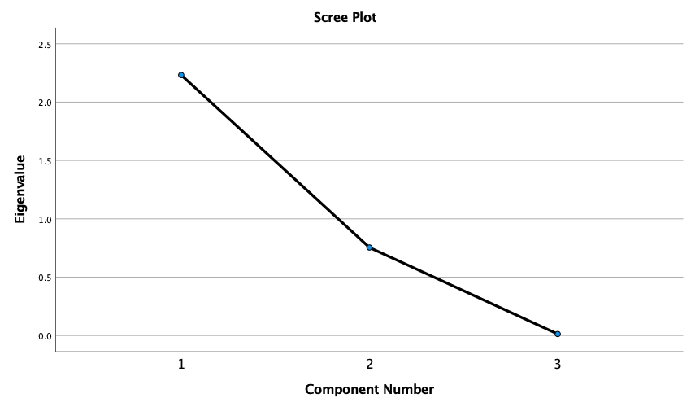

Component Matrixª
 | Raw |  |  | Rescaled
 | Component |  |  | Component
 | 1 | 2 | 3 | 1 | 2 | 3
ZTransit | .973 | -.215 | .082 | .973 | -.215 | .082
ZResidental | -.954 | .288 | .079 | -.954 | .288 | .079
ZGrocery | .612 | .791 | -.007 | .612 | .791 | -.007

Extraction Method: Principal Component Analysis.ª
a. 3 components extracted.

Rotated Component Matrixª
 | Raw |  |  | Rescaled
 | Component |  |  | Component
 | 1 | 2 | 3 | 1 | 2 | 3
ZResidental | -.983 | -.166 | .075 | -.983 | -.166 | .075
ZTransit | .968 | .237 | .086 | .968 | .237 | .086
ZGrocery | .198 | .980 | .003 | .198 | .980 | .003

Extraction Method: Principal Component Analysis.
Rotation Method: Varimax with Kaiser Normalization.ª
a. Rotation converged in 3 iterations.

Component Transformation Matrix
Component | 1 | 2 | 3
1 | .897 | .443 | .006
2 | -.443 | .897 | .007
3 | -.003 | -.010 | 1.000

Extraction Method: Principal Component Analysis.
Rotation Method: Varimax with Kaiser Normalization.

